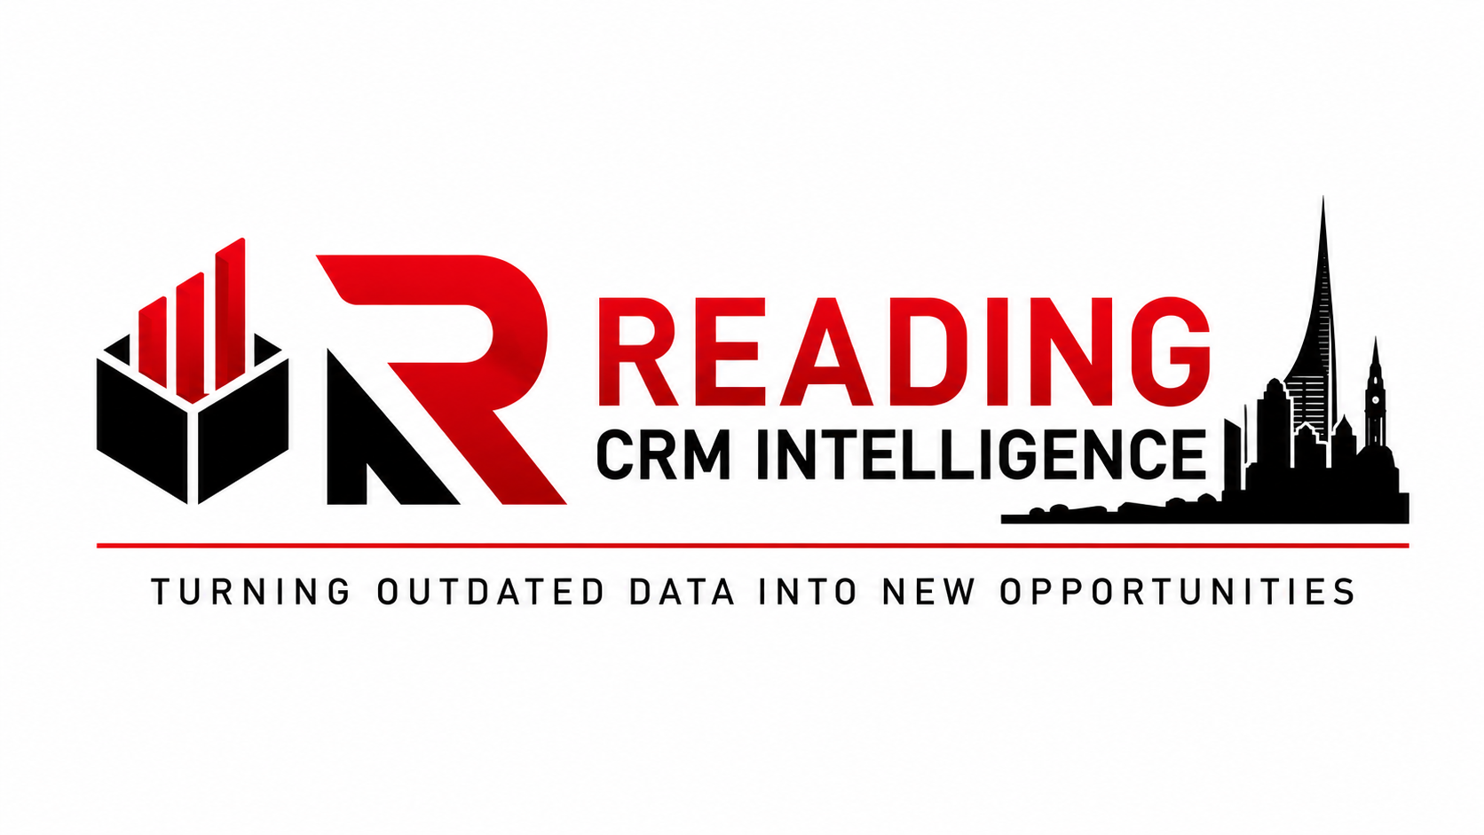

1. Welcome
Thank you for choosing Reading CRM Intelligence. This guide explains how we work, what you can expect from us, what we require from you and the basis on which our services are provided. It is designed to ensure both parties have a clear understanding of the project before work begins.

2. What We Do
We improve the quality and commercial value of existing CRM databases. We research organisations, verify existing business information where possible, identify current decision-makers and enrich CRM records using reputable publicly available business information.
- CRM Intelligence
- Organisation research
- Decision-maker identification
- Contact verification where possible
- CRM optimisation and enrichment

3. Our Project Process
- Discovery discussion and quotation.
- Statement of Work agreed.
- Secure transfer of your CRM data.
- Research and verification will begin only after payment has been received in accordance with the agreed quotation or invoice terms.
- Quality assurance review.
- Delivery of agreed outputs.
- Project sign-off and secure deletion or agreed retention of data.

4. What We Need From You
- A copy of the CRM data or agreed project information.
- A named contact for project queries.
- Clear priorities and objectives.
- Prompt responses where clarification is required.

5. What You Will Receive
You will receive a single completed CRM spreadsheet containing the contact and company information researched and verified for the companies agreed in your Statement of Work, including, where publicly available, contact names, job titles, business email addresses, company telephone numbers and LinkedIn profile links. Where fewer than three suitable contacts can be identified for a company, we will provide the best information reasonably available rather than leave records incomplete.

6. What To Expect
We will keep communication professional and straightforward. If we discover issues likely to affect the agreed scope or timescale, we will discuss them with you before carrying out additional work.

7. Research Standards
Our research is based on reputable publicly available business information including official company websites, Companies House, professional networking platforms and other legitimate commercial sources. Where practical, information is cross-checked before being added to your CRM.

8. Data Security & Confidentiality
Your CRM data remains your property at all times. It is used only for the agreed project, treated as commercially confidential and handled in accordance with UK GDPR and our documented data handling procedures.

9. Important Service Limitations
- We do not guarantee sales, meetings or commercial success.
- We cannot guarantee every record can be verified.
- Where a contact we identify matches one you already hold, this confirms they remain the strongest and most relevant point of contact within that organisation — it is not treated as an error on our part, and no free replacement contact will be provided in this instance.
- We do not buy or sell generic contact lists.
- We use information available at the time of research; organisations and personnel may change after project completion.
- Any work outside the agreed Statement of Work will require approval before it is undertaken.

10. Cancellation & Refunds
As research and project work only begin once payment has been received, the following cancellation terms apply:
- If you cancel before research work has commenced, a full refund will be issued, less any payment processing fees already incurred.
- If you cancel after research work has commenced, we will invoice for the proportion of companies already researched and refund the remaining balance.
- Once a project has been completed and deliverables have been provided, no refund will be issued.
- Changes to the agreed scope after work has commenced will be treated as a new Statement of Work and quoted separately.

11. Client Acceptance
Payment Terms
Research and project work will commence only after cleared payment has been received, unless alternative written payment terms have been agreed in advance by Reading CRM Intelligence.
By signing below, the Client confirms that they have read this guide, understand the scope of the agreed project, accept the quotation and Statement of Work, authorise Reading CRM Intelligence to begin work and acknowledge the service limitations described above.
Client
Company
Project Reference
Authorised Signature
Name
Date

